*IMPACT ANALYSIS –* Core-IR ACHReader-IA-01*- CR*

**Document ID:** VR- Core-IR ACHReader-IA-01

**Author(s):** Aishwarya R

**Version:** 1.0

**Date:** 27-Oct- 2022

Table of Contents

1. Scope of work 2

2. Current work status 2

3. Work impact areas 2

3.1 Version to be impacted 2

3.2 Functionality impact 2

3.3 User interface impact 2

3.4 Architecture / Design impact 3

3.5 Modified source code 3

3.6 Database impact 4

4. Assumptions 4

5. Document to be updated 4

6. Modification History 4

# 1.Scope of work

ACH Reader:ACH Reader helps to upload the ACH format file and read the necessary details from the file and display the required information in the grid and also export it to the excel sheet

# 2.Current work status

Nil

# 3.1Version to be impacted

Nil

# 3.2 Functionality impact

Since ACH reader is a new page it won’t be affecting any other existing page

# 3.3 User interface impact

We have added a file upload functionality in the page to upload only text files under Administration->SystemSettings-->ACHReader

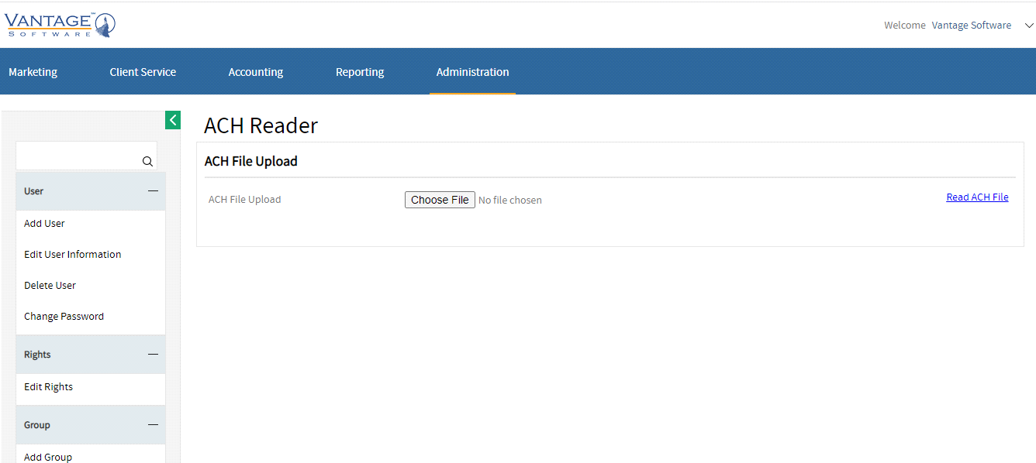

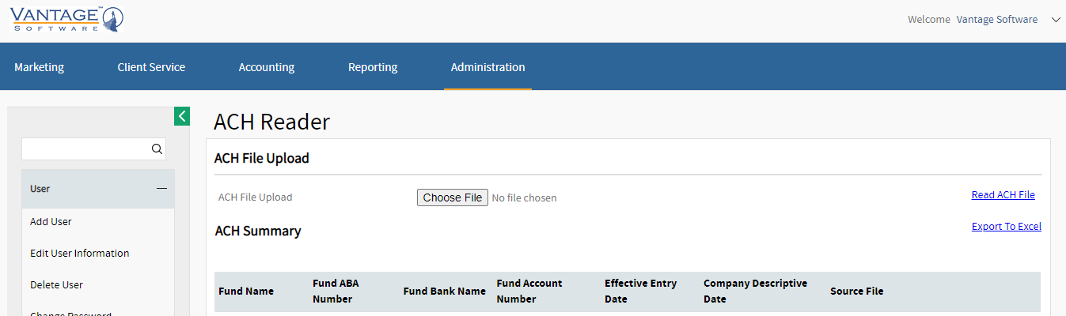





# 3.4 Architecture / Design impact

Nil

# 3.5Modified source code

Modified source code

* New pages:
* ACHReader is added in VantageInvestor-->Admin-->Common folder

# 3.6Database impact

* VRMenu: Adding new column ACH Reader with MenuID- 2.4.9
* VRUserRights: Adding new right for admin group with MenuID- 2.4.9

# 4.Assumptions

Nil

# 5.Document to be updated

Nil

# 6.Modification History

|  |  |  |  |
| --- | --- | --- | --- |
| Date | Author(s) | Modification History | Version |
| 27-Oct-2022 | Aishwarya N | Intital document creation | 0.1 |
| 28-Oct-2022 | Suganthi Ravi | Reviewed the document | 0.2 |
| 28-Oct-2022 | Aishwarya N | Final version updated | 1.0 |